Freeform Straight-Line Shapes

Definition
# Source: AI Source: Provided by: [Data Path: Persons Table -> ID Column: 1, Name_En Column: Motasem Essam] -> From: [ChatGPT] on [7/25/2026]
Freeform Straight-Line Shapes are shapes whose boundaries are composed primarily of straight-line segments arranged without following a fixed standard geometric form or predetermined regular pattern.
They use straight edges, but the overall shape is freely designed rather than being restricted to a standard polygon such as a triangle, square, or regular pentagon.
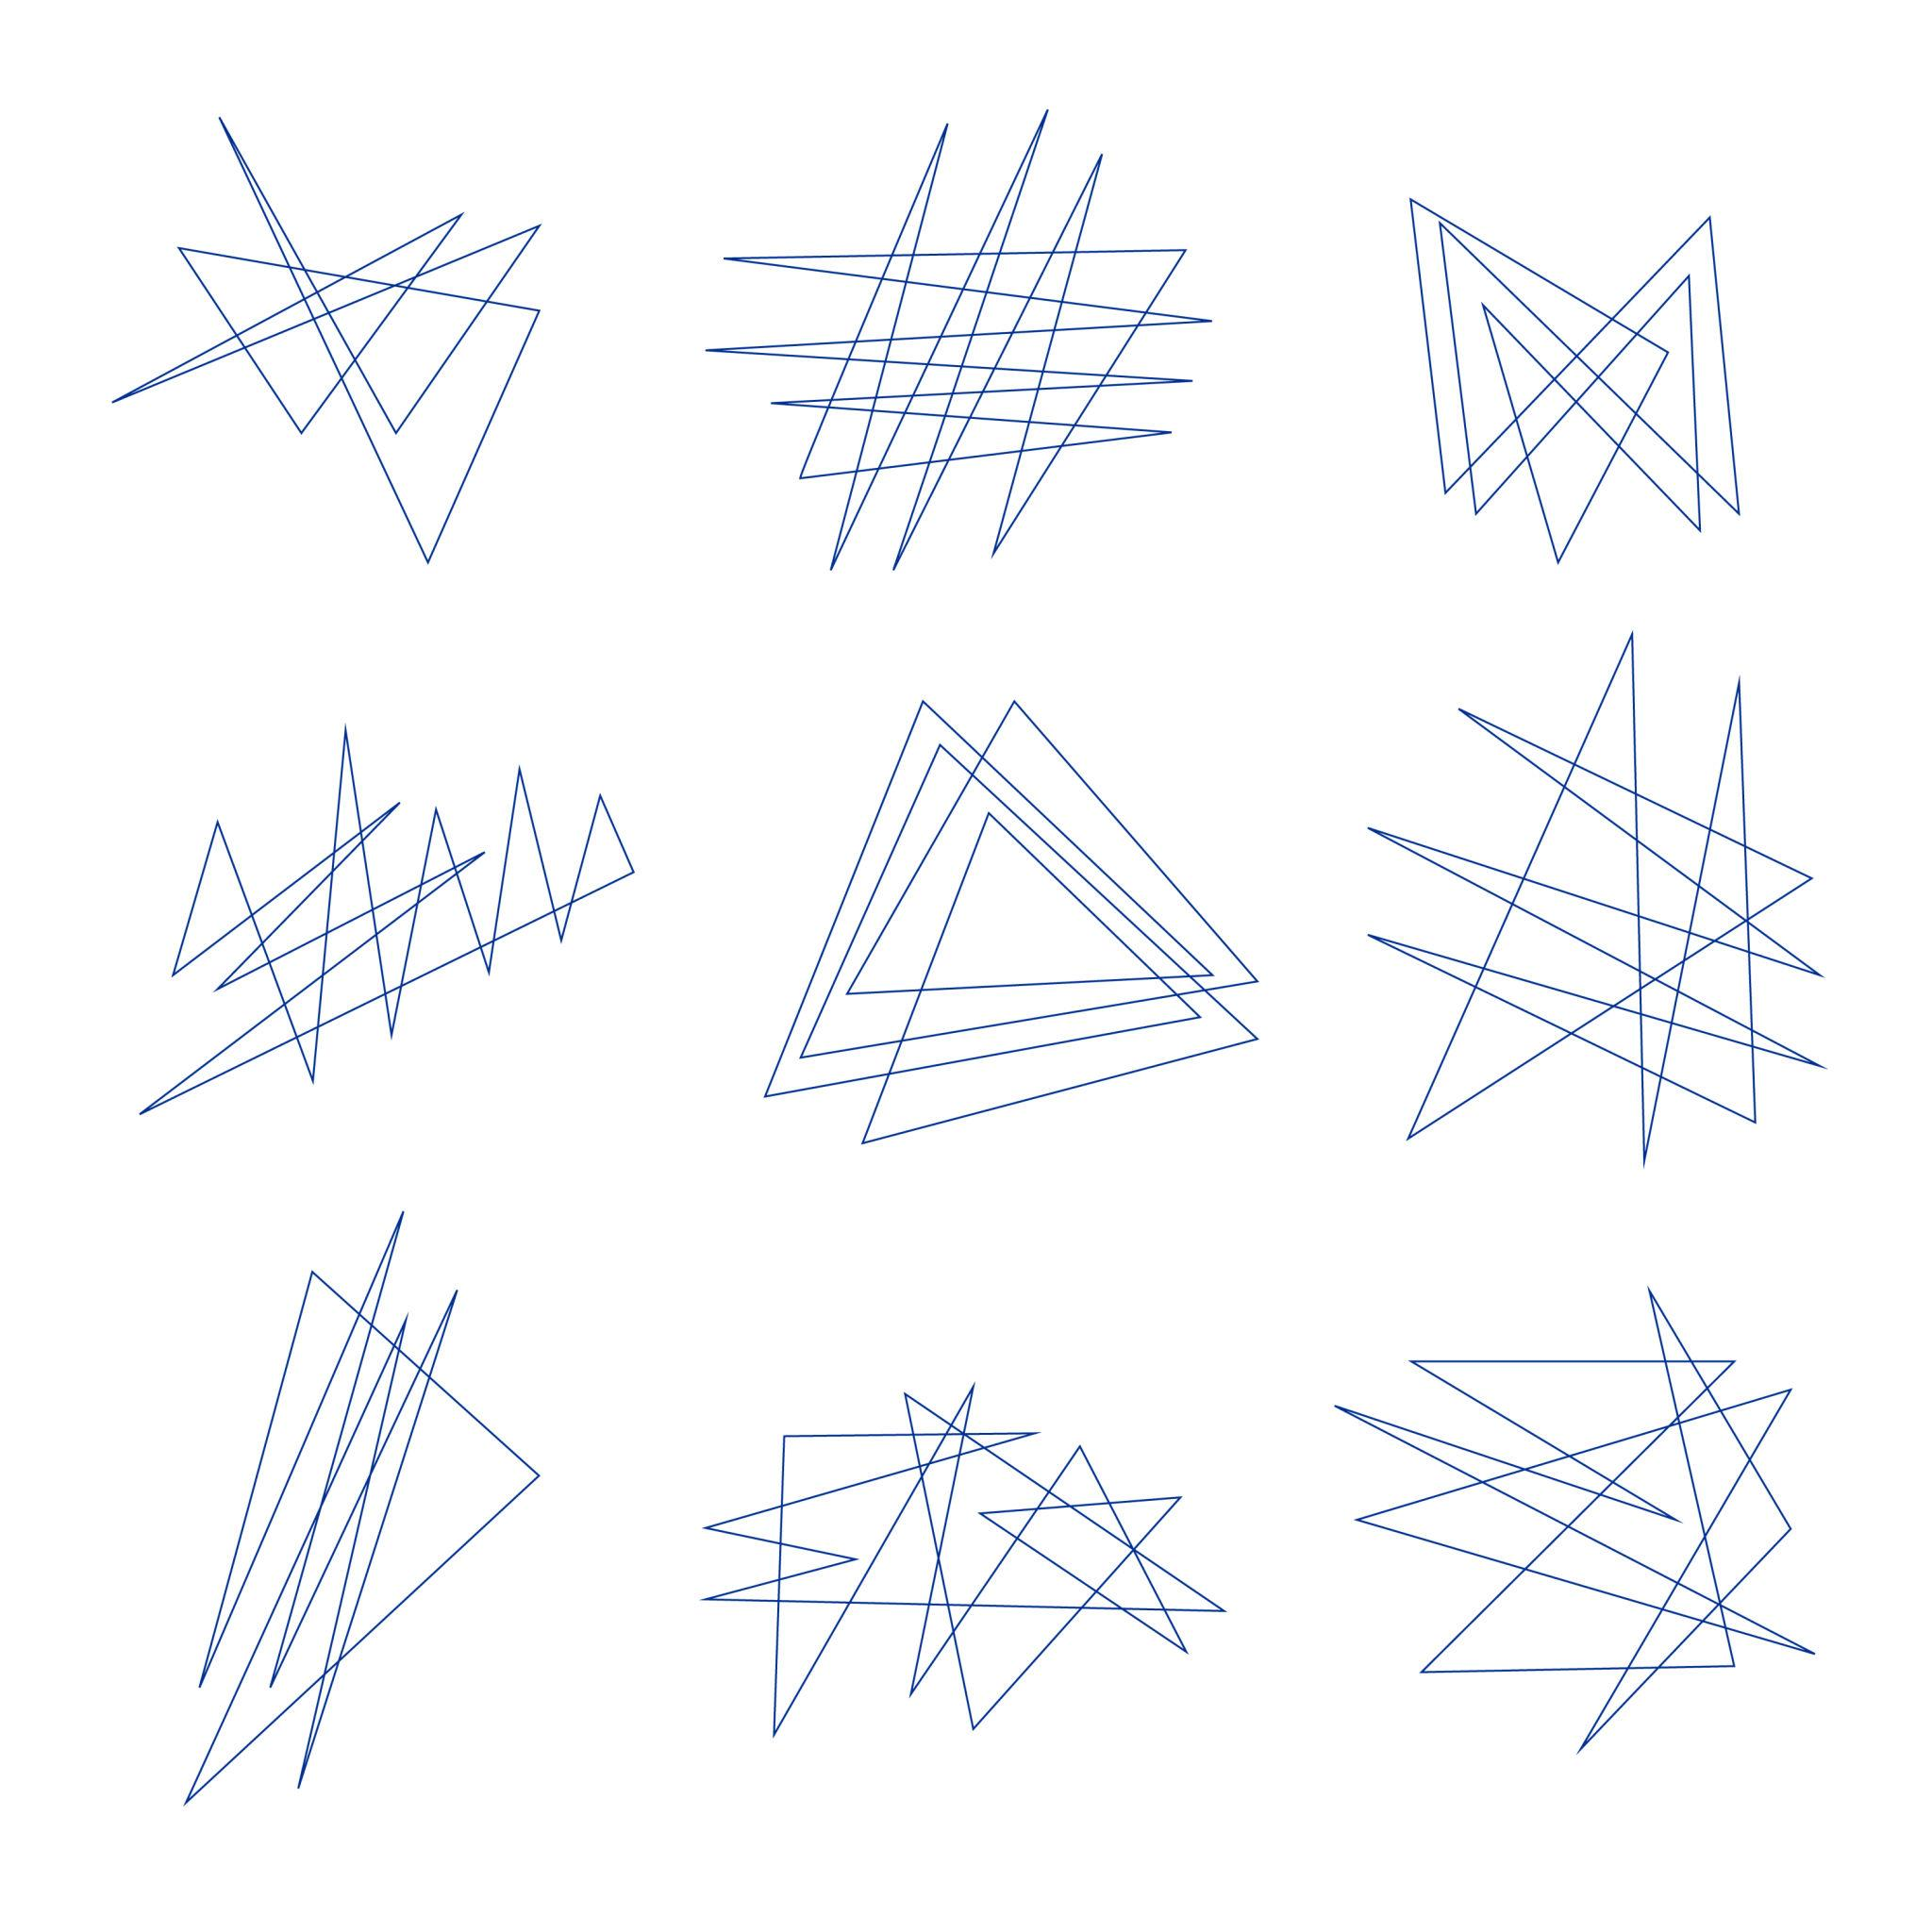
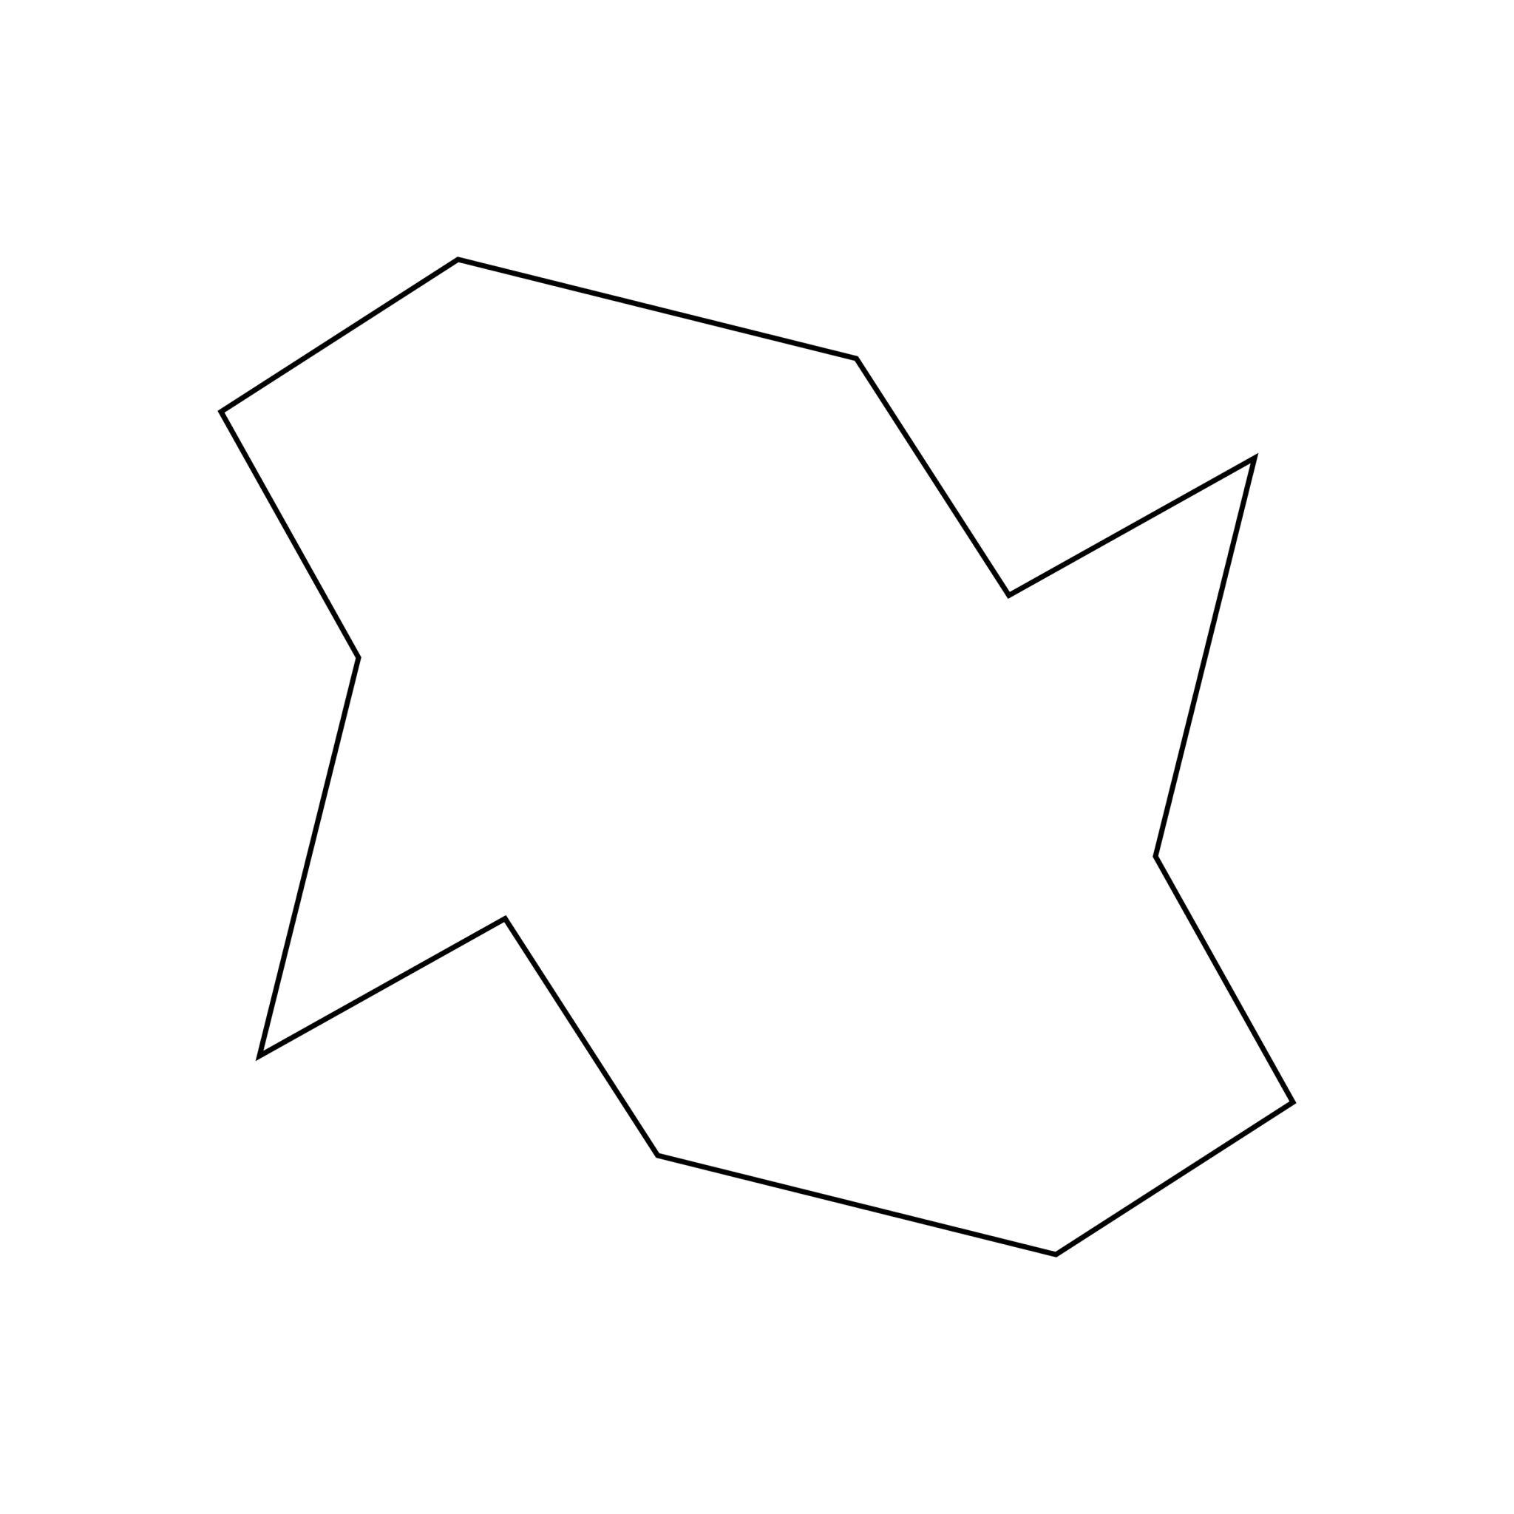
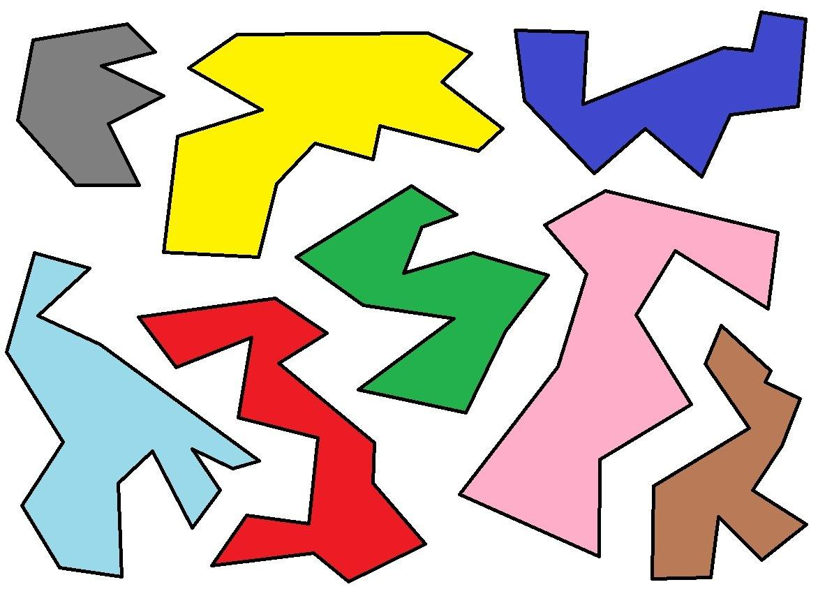
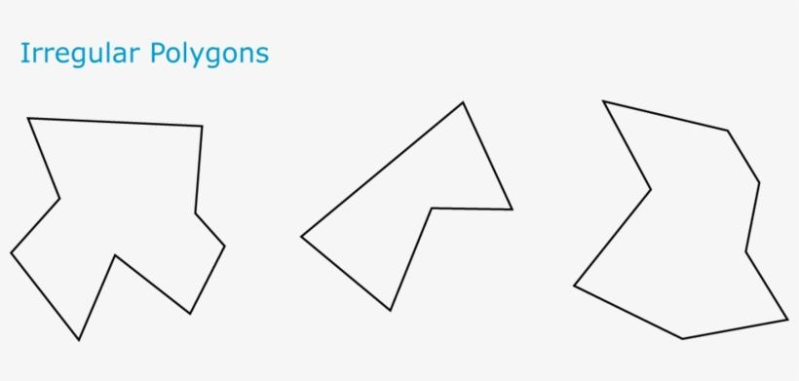
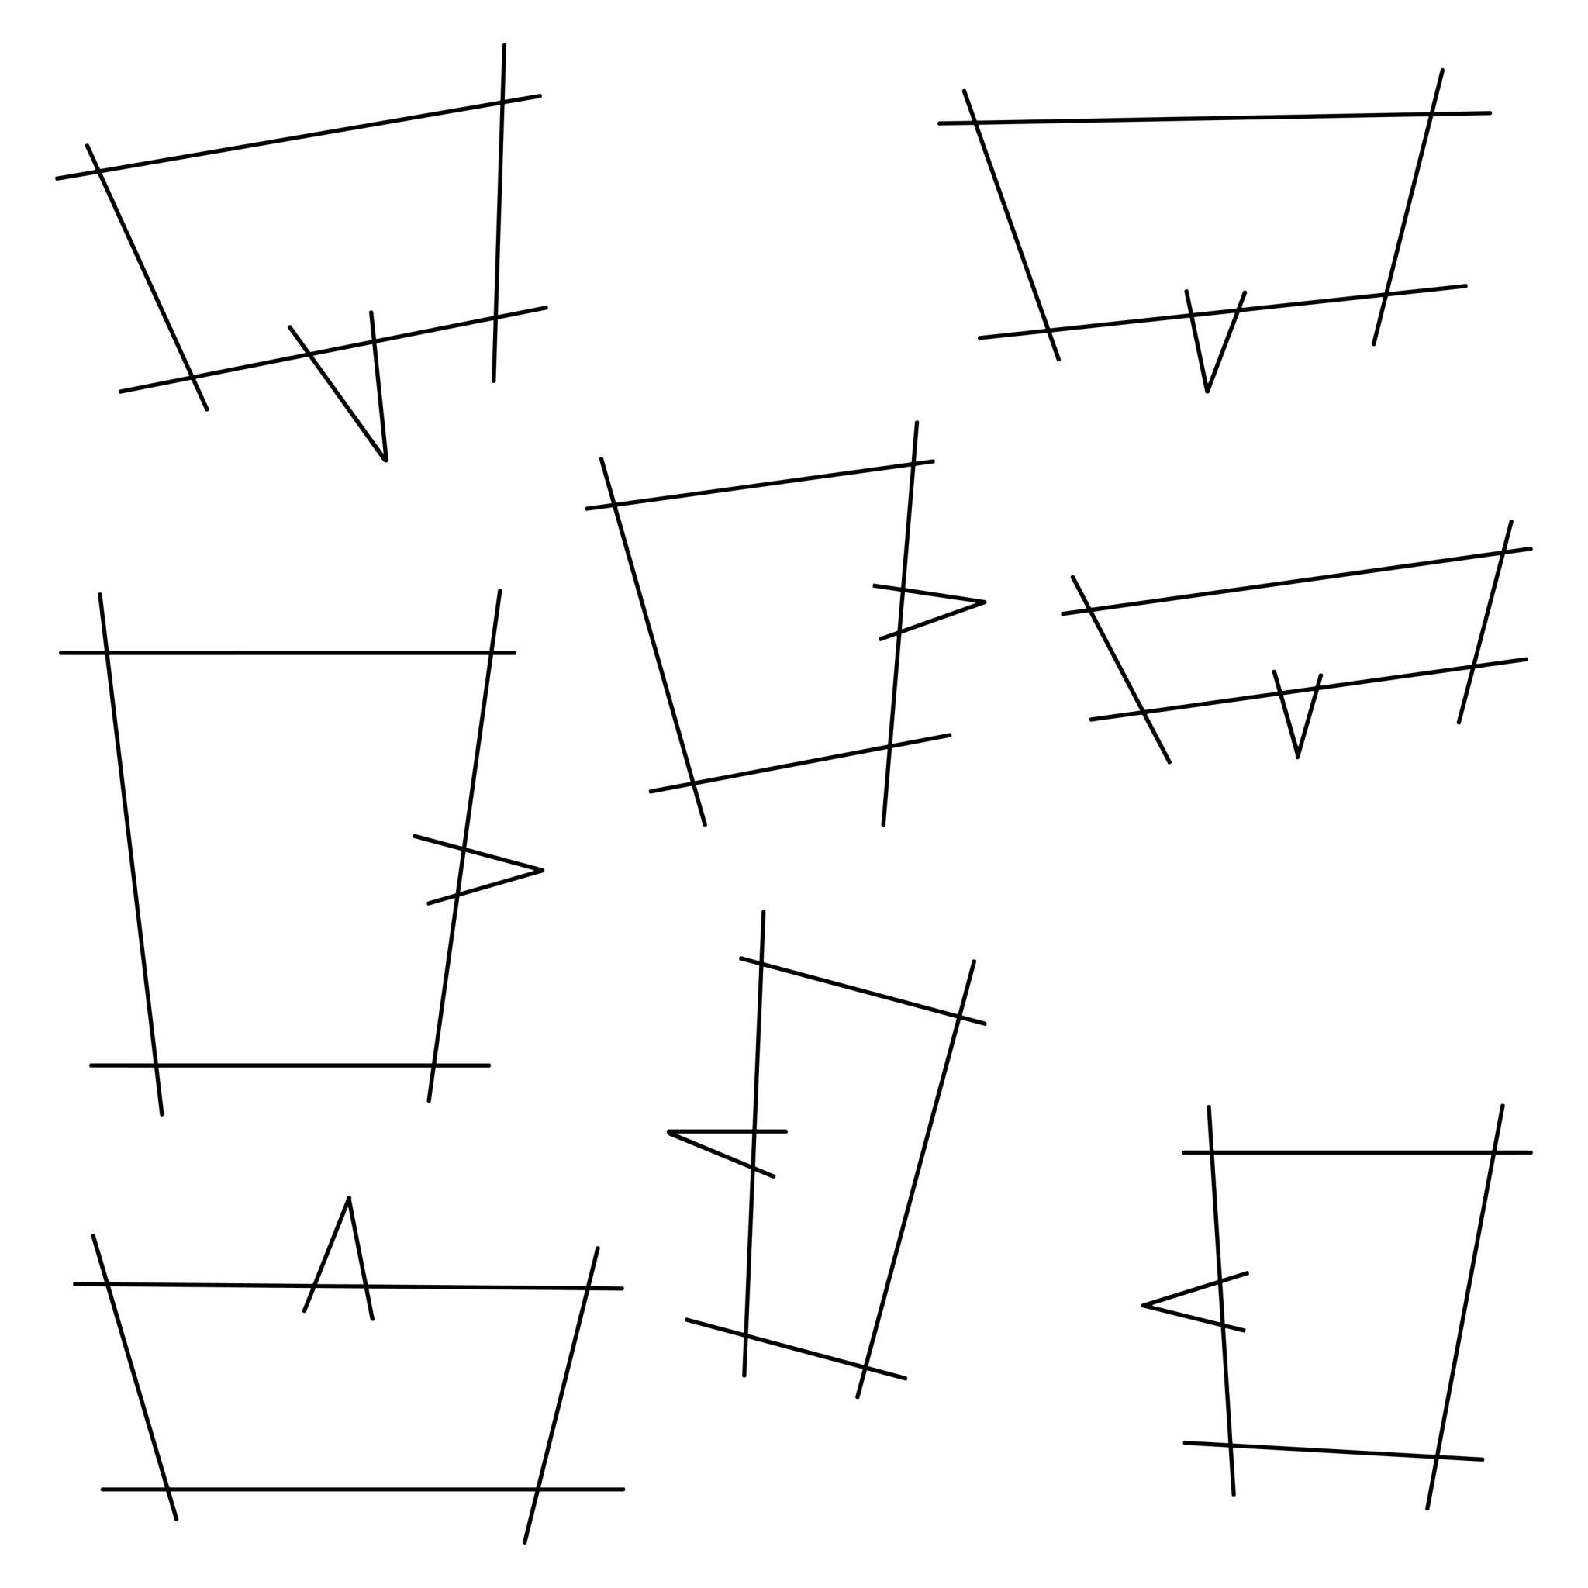
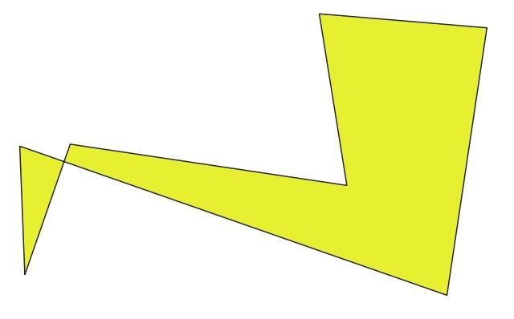

Fundamental Concept
# Source: AI Source: Provided by: [Data Path: Persons Table -> ID Column: 1, Name_En Column: Motasem Essam] -> From: [ChatGPT] on [7/25/2026]
The fundamental idea is:
Straight-line segments + flexible arrangement + no fixed standard form
For example, a boundary may be constructed from segments with different:
- lengths
- directions
- angles
- proportions
- numbers of sides
A simple closed example is therefore technically a polygon, but its particular shape is freeform rather than a standard named polygon.

Main Characteristics
# Source: AI Source: Provided by: [Data Path: Persons Table -> ID Column: 1, Name_En Column: Motasem Essam] -> From: [ChatGPT] on [7/25/2026]
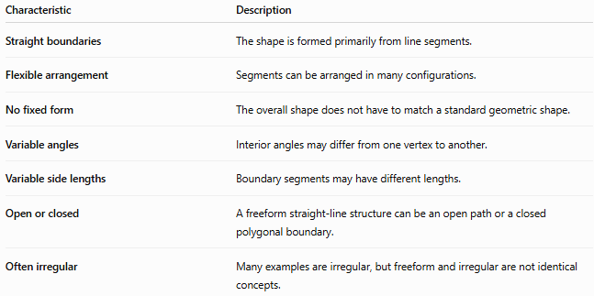
Characteristic | Description
Straight boundaries | The shape is formed primarily from line segments.
Flexible arrangement | Segments can be arranged in many configurations.
No fixed form | The overall shape does not have to match a standard geometric shape.
Variable angles | Interior angles may differ from one vertex to another.
Variable side lengths | Boundary segments may have different lengths.
Open or closed | A freeform straight-line structure can be an open path or a closed polygonal boundary.
Often irregular | Many examples are irregular, but freeform and irregular are not identical concepts.

Basic Structure
# Source: AI Source: Provided by: [Data Path: Persons Table -> ID Column: 1, Name_En Column: Motasem Essam] -> From: [ChatGPT] on [7/25/2026]
A freeform straight-line shape can be constructed from connected line segments:
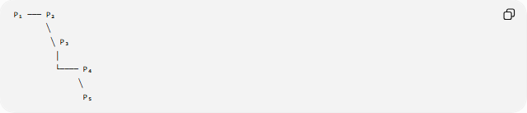
P₁ ─── P₂
╲
╲ P₃
│
└──── P₄
╲
P₅
For a closed shape:
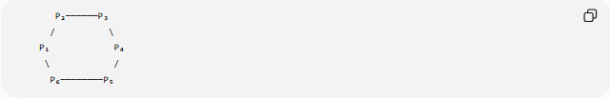
P₂──────P₃
/ \
P₁ P₄
\ /
P₆────────P₅
If the boundary is closed and non-self-intersecting, it forms a polygon.

Types of Freeform Straight-Line Shapes
# Source: AI Source: Provided by: [Data Path: Persons Table -> ID Column: 1, Name_En Column: Motasem Essam] -> From: [ChatGPT] on [7/25/2026]
A useful descriptive classification is:
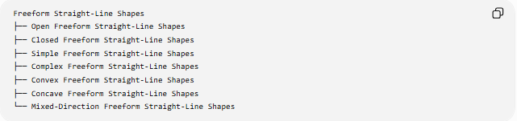
Freeform Straight-Line Shapes
├── Open Freeform Straight-Line Shapes
├── Closed Freeform Straight-Line Shapes
├── Simple Freeform Straight-Line Shapes
├── Complex Freeform Straight-Line Shapes
├── Convex Freeform Straight-Line Shapes
├── Concave Freeform Straight-Line Shapes
└── Mixed-Direction Freeform Straight-Line Shapes
These categories can overlap.
For example, a shape can be:
Closed + Simple + Concave + Freeform Straight-Line

Open Freeform Straight-Line Shapes
# Source: AI Source: Provided by: [Data Path: Persons Table -> ID Column: 1, Name_En Column: Motasem Essam] -> From: [ChatGPT] on [7/25/2026]
Open Freeform Straight-Line Shapes are connected arrangements of straight segments that have two endpoints and do not enclose a region.
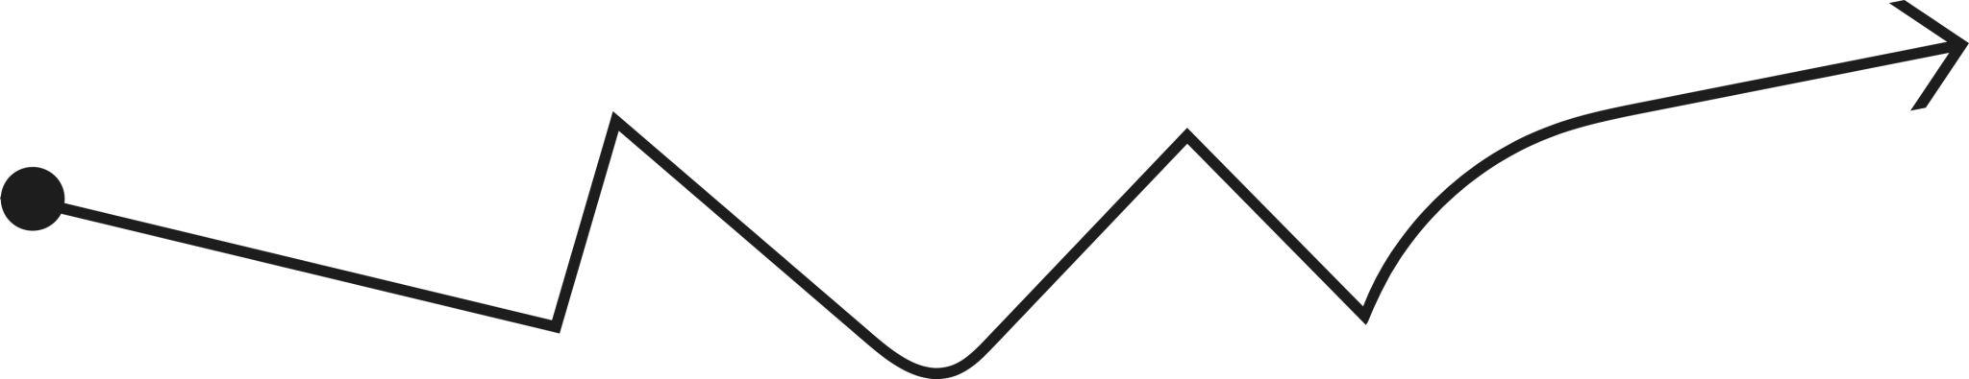
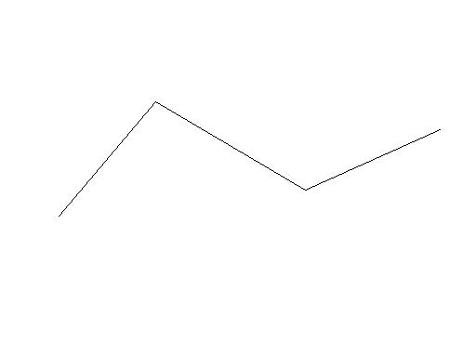
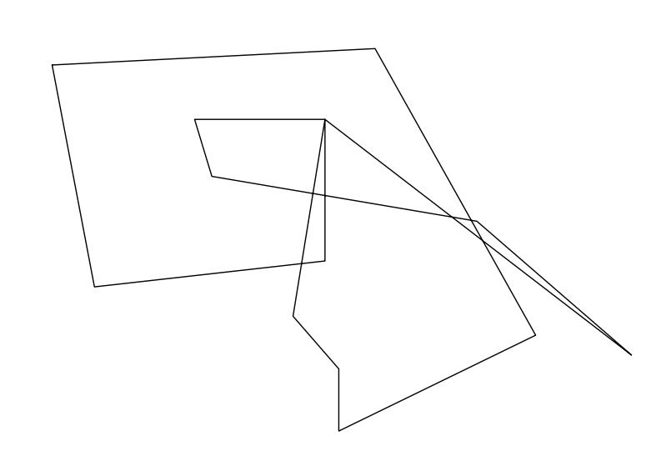
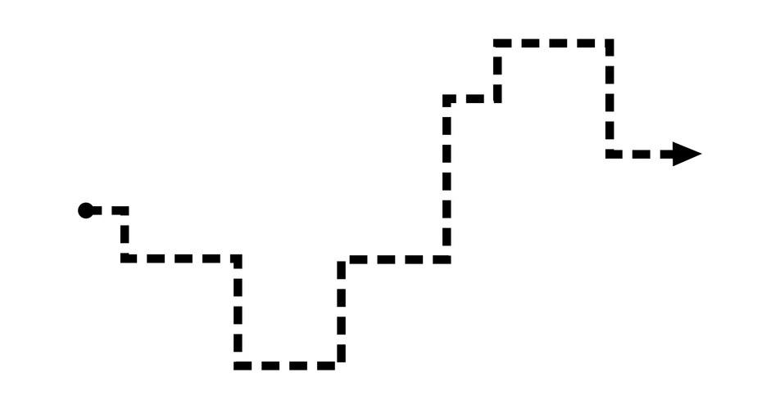
If the path has $n$vertices:
$$P_{1},P_{2},…,P_{n}$$
then it contains:
$$n-1$$
line segments.
Its total length is:
$$\boxed{L=\sum_{i=1}^{n-1}{∣}P_{i}P_{i+1}∣}$$

Closed Freeform Straight-Line Shapes
# Source: AI Source: Provided by: [Data Path: Persons Table -> ID Column: 1, Name_En Column: Motasem Essam] -> From: [ChatGPT] on [7/25/2026]
A Closed Freeform Straight-Line Shape is formed when the final point connects back to the starting point:
$$P_{n}=P_{1}$$
If it is also simple and non-self-intersecting, it is a polygon.
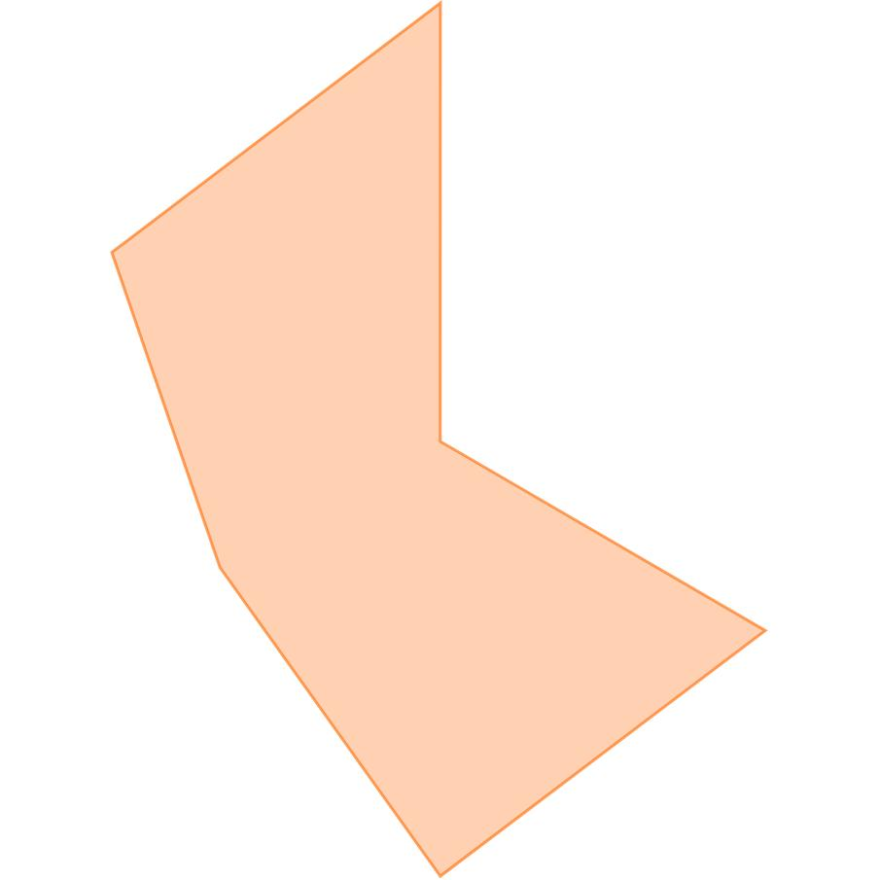
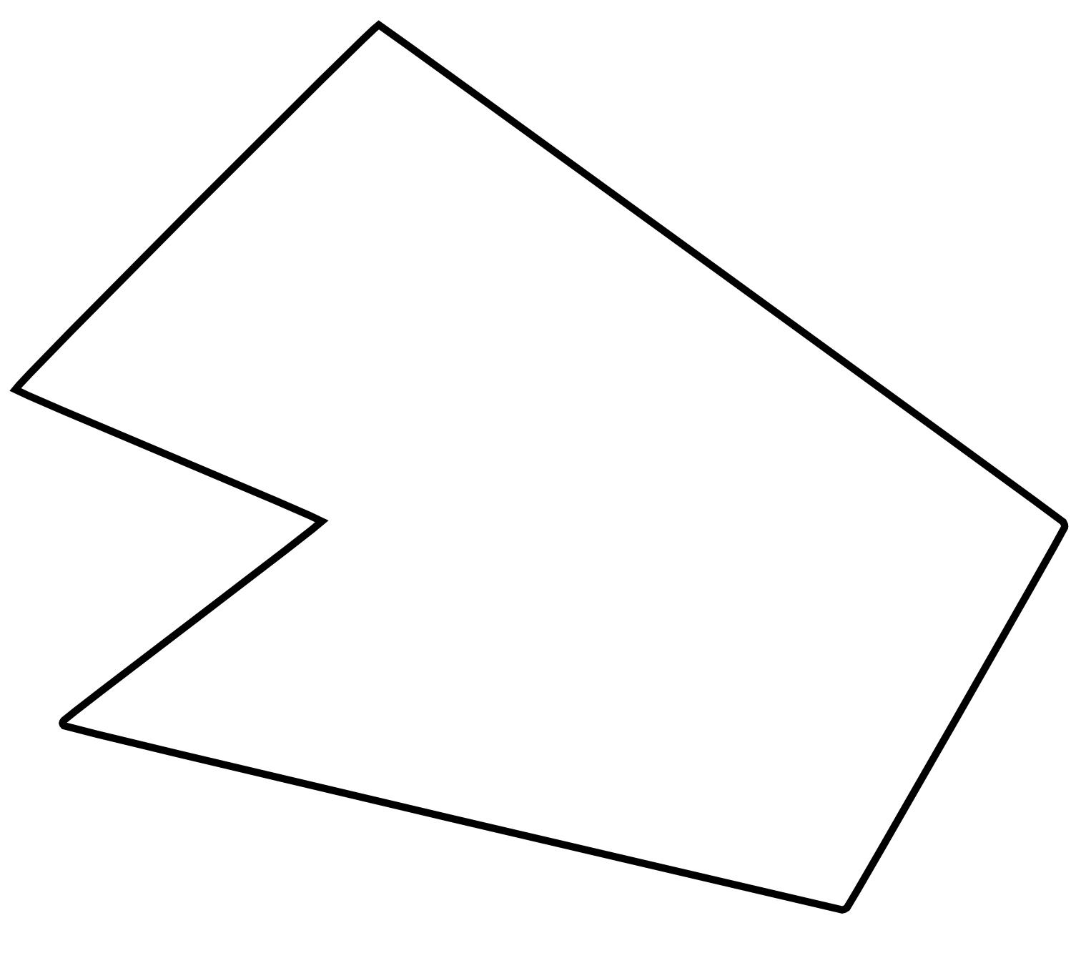
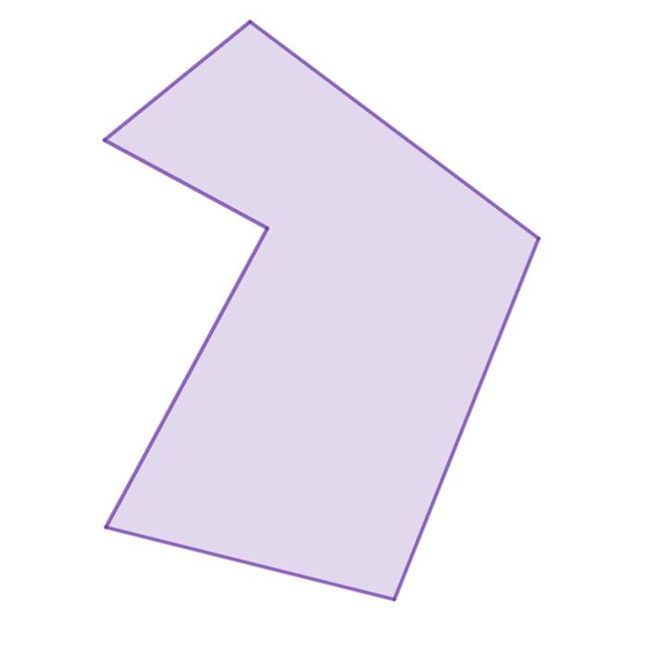
For a simple polygon with $n$sides, the interior-angle sum is:
$$\boxed{\left(n-2\right){180}^{∘}}$$

Simple Freeform Straight-Line Shapes
# Source: AI Source: Provided by: [Data Path: Persons Table -> ID Column: 1, Name_En Column: Motasem Essam] -> From: [ChatGPT] on [7/25/2026]
A Simple Freeform Straight-Line Shape has straight-line boundaries that do not cross themselves.
If closed, it is a simple polygon.
Examples include:
- irregular pentagons
- irregular hexagons
- irregular concave polygons
- custom polygonal outlines
A simple freeform polygon can have:
$$n≥3$$
sides.

Complex Freeform Straight-Line Shapes
# Source: AI Source: Provided by: [Data Path: Persons Table -> ID Column: 1, Name_En Column: Motasem Essam] -> From: [ChatGPT] on [7/25/2026]
Complex Freeform Straight-Line Shapes contain more complicated arrangements of straight-line segments.
The term complex is descriptive rather than a universally standardized mathematical polygon classification.
If the boundary crosses itself, the more precise mathematical term is:
Self-Intersecting Polygonal Path or Self-Intersecting Polygon
For example:
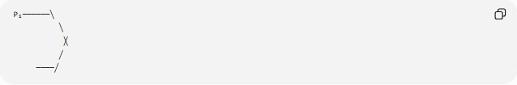
P₁──────╲
╲
╳
╱
────╱
A self-intersecting shape should not automatically be treated using the ordinary formulas for a simple polygon.

Convex Freeform Straight-Line Shapes
# Source: AI Source: Provided by: [Data Path: Persons Table -> ID Column: 1, Name_En Column: Motasem Essam] -> From: [ChatGPT] on [7/25/2026]
A Convex Freeform Straight-Line Shape has no inward indentation.
For a convex polygon:
$$0^{∘}<θ_{i}<{180}^{∘}$$
for every interior angle $θ_{i}$.
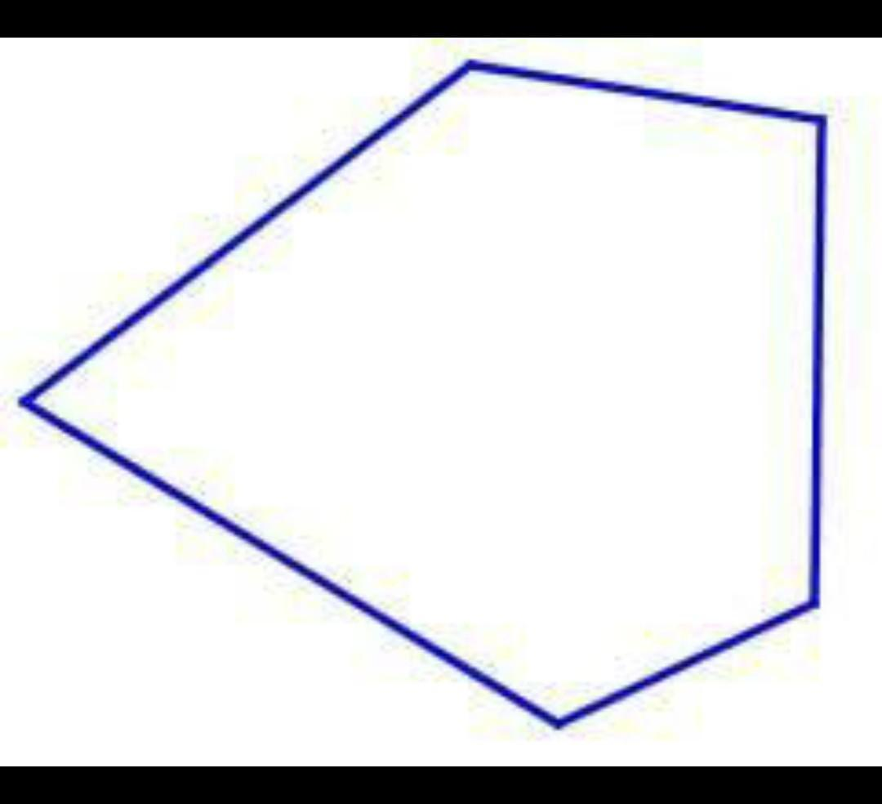
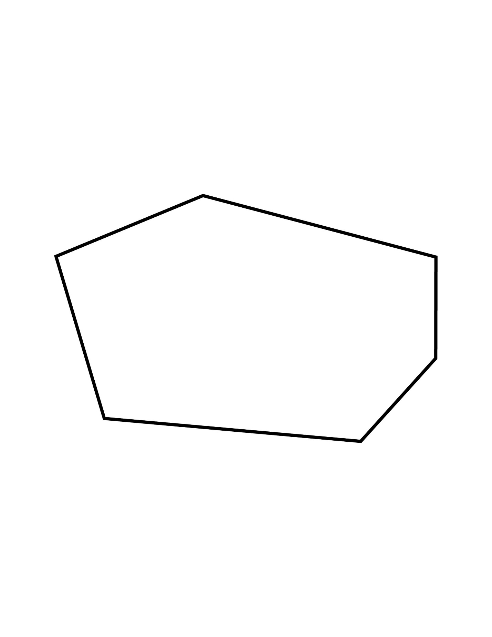
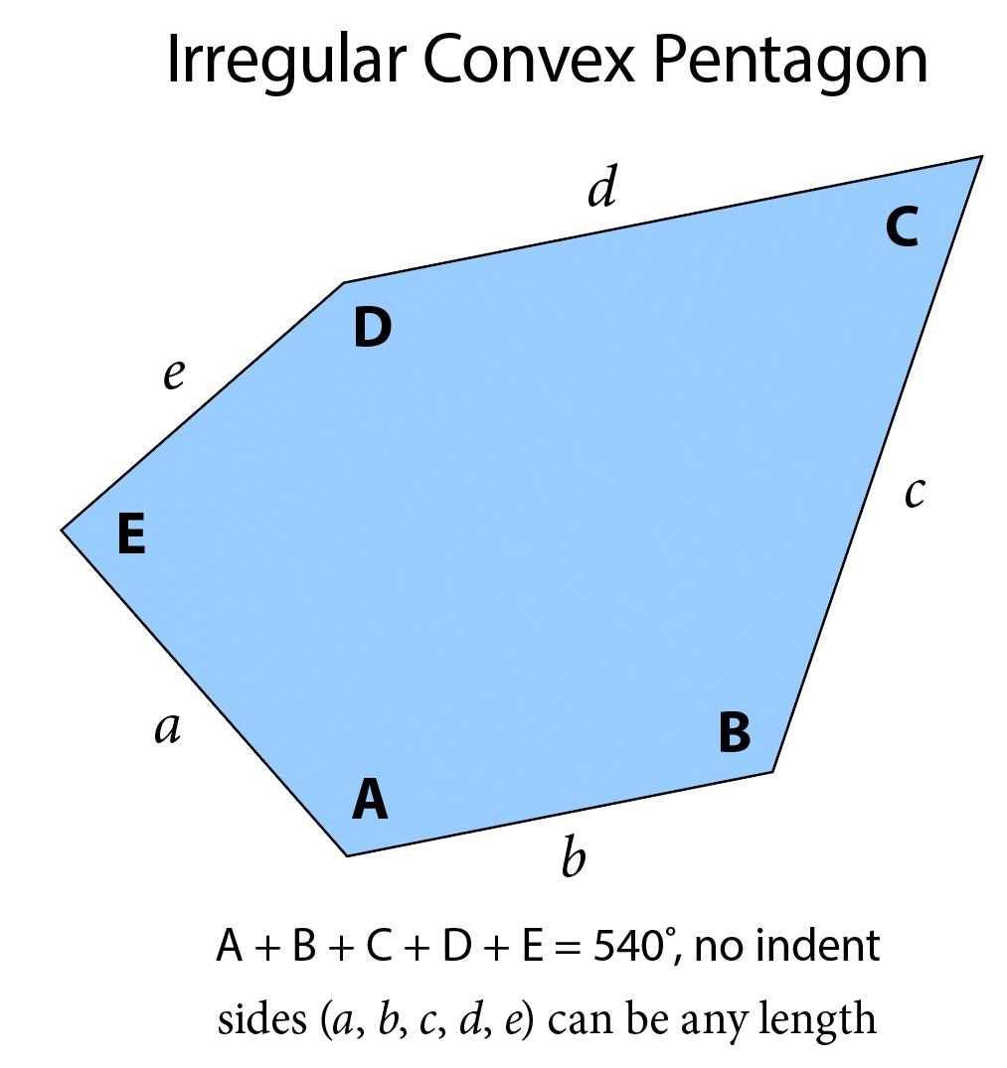
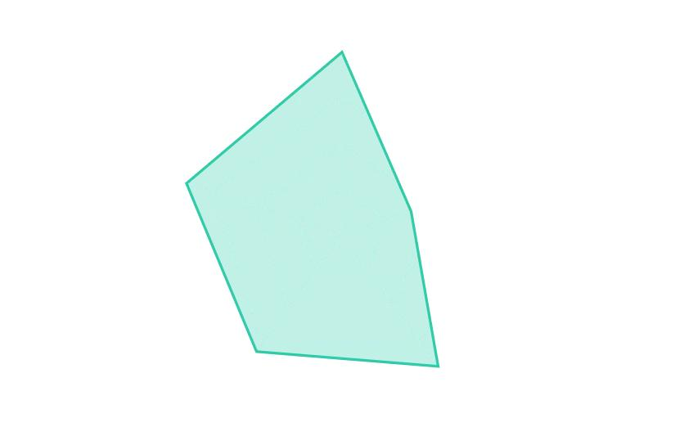
A convex polygon can be highly irregular while still being freeform.
For example, an irregular hexagon can be:
- straight-edged
- convex
- non-regular
- freeform

Concave Freeform Straight-Line Shapes
# Source: AI Source: Provided by: [Data Path: Persons Table -> ID Column: 1, Name_En Column: Motasem Essam] -> From: [ChatGPT] on [7/25/2026]
A Concave Freeform Straight-Line Shape has at least one inward indentation.
A concave polygon has at least one reflex interior angle:
$${180}^{∘}<θ<{360}^{∘}$$
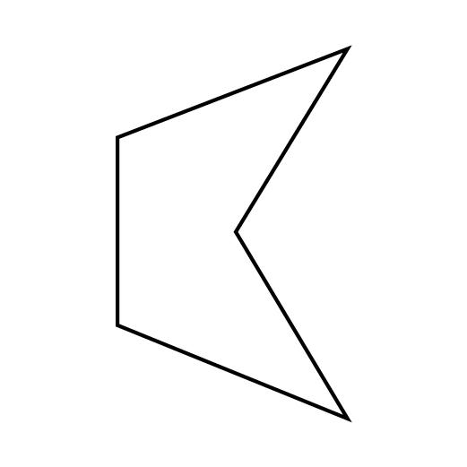
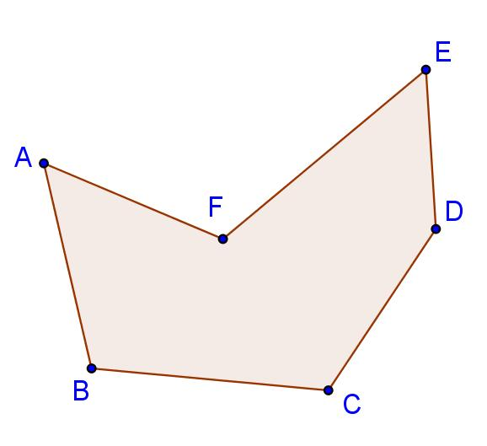
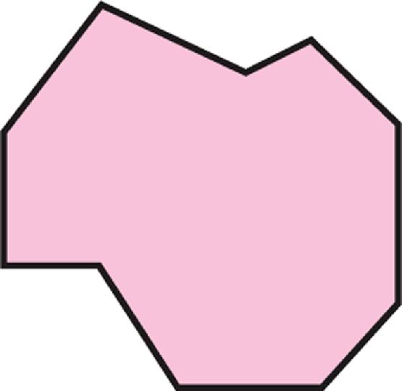
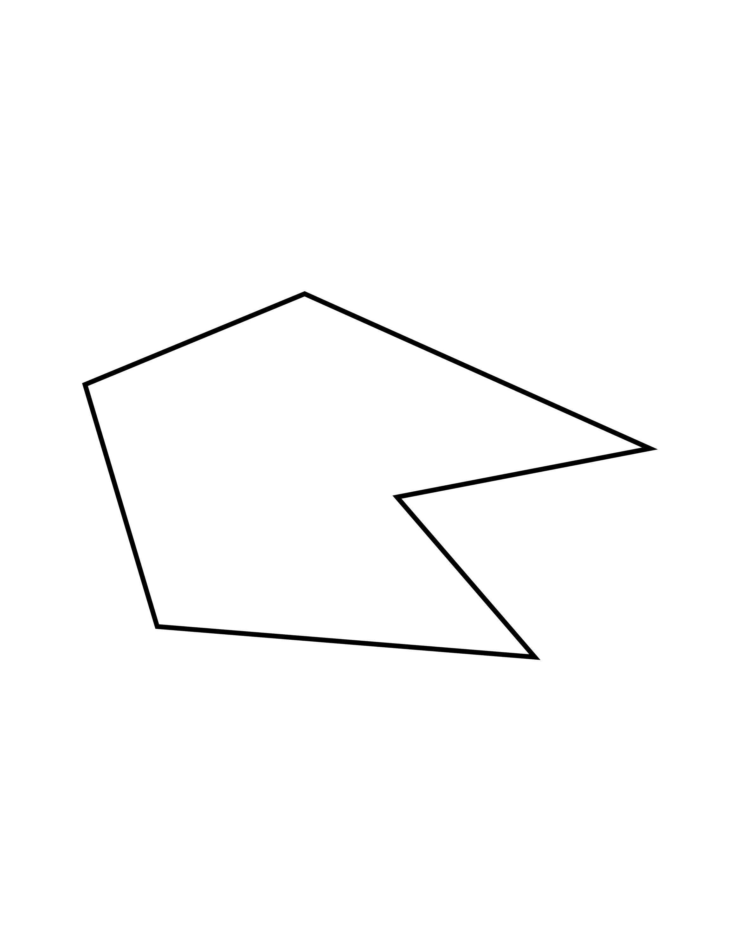
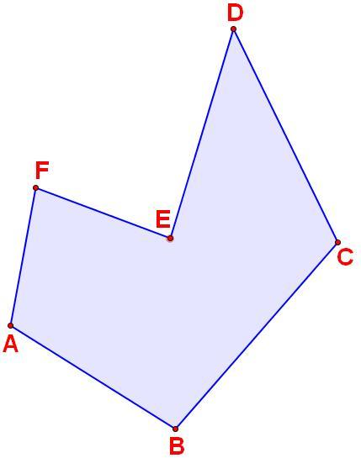
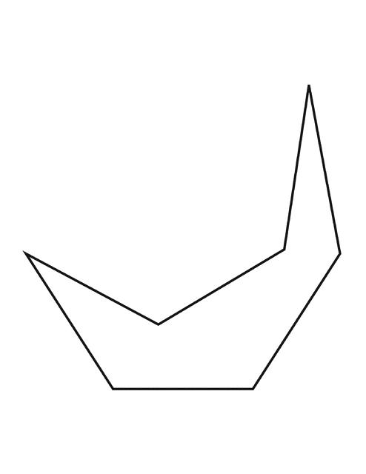
Common examples include custom:
- L-shaped forms
- U-shaped forms
- step-shaped forms
- irregular polygonal outlines

Mixed-Direction Freeform Straight-Line Shapes
# Source: AI Source: Provided by: [Data Path: Persons Table -> ID Column: 1, Name_En Column: Motasem Essam] -> From: [ChatGPT] on [7/25/2026]
A Mixed-Direction Freeform Straight-Line Shape contains line segments extending in different directions.
For example:
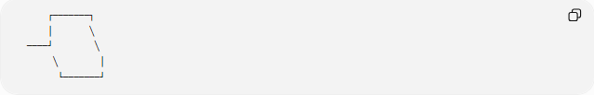
┌───────┐
│ ╲
────┘ ╲
╲ │
└───────┘
The segments may be:
- horizontal
- vertical
- diagonal
- oblique
There is no requirement that all segments follow a common direction system.

Mathematical Representation
# Source: AI Source: Provided by: [Data Path: Persons Table -> ID Column: 1, Name_En Column: Motasem Essam] -> From: [ChatGPT] on [7/25/2026]
A straight-line boundary can be represented using vertices:
$$P_{i}=\left(x_{i} , y_{i}\right)$$
A segment joining:
$$P_{i}=\left(x_{i} , y_{i}\right)$$
and
$$P_{i+1}=\left(x_{i+1} , y_{i+1}\right)$$
has length:
$$\boxed{L_{i}=\sqrt{{\left(x_{i+1}-x_{i}\right)}^{2}+{\left(y_{i+1}-y_{i}\right)}^{2}}}$$
The total perimeter of a closed $n$-sided shape is:
$$\boxed{P=\sum_{i=1}^{n}{L_{i}}}$$
with:
$$P_{n+1}=P_{1}$$

Area of a Freeform Straight-Line Shape
# Source: AI Source: Provided by: [Data Path: Persons Table -> ID Column: 1, Name_En Column: Motasem Essam] -> From: [ChatGPT] on [7/25/2026]
If the shape is a simple closed polygon with vertices:
$$\left(x_{1} , y_{1}\right),\left(x_{2} , y_{2}\right),…,\left(x_{n} , y_{n}\right)$$
its area can be calculated using the shoelace formula:
$$\boxed{A=\frac{1}{2}∣\sum_{i=1}^{n}{(}\left.x_{i}y_{i+1}-y_{i}x_{i+1}\right)∣}$$
where:
$$x_{n+1}=x_{1}, y_{n+1}=y_{1}$$
This formula applies directly to simple closed polygonal boundaries.

Freeform Straight-Line Shapes vs. Regular Polygons
# Source: AI Source: Provided by: [Data Path: Persons Table -> ID Column: 1, Name_En Column: Motasem Essam] -> From: [ChatGPT] on [7/25/2026]
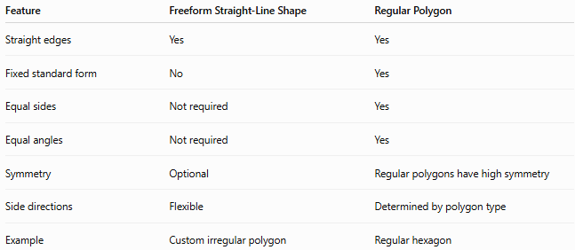
Feature | Freeform Straight-Line Shape | Regular Polygon
Straight edges | Yes | Yes
Fixed standard form | No | Yes
Equal sides | Not required | Yes
Equal angles | Not required | Yes
Symmetry | Optional | Regular polygons have high symmetry
Side directions | Flexible | Determined by polygon type
Example | Custom irregular polygon | Regular hexagon
A freeform straight-line shape may therefore be a polygon without being a regular polygon.

Freeform Straight-Line Shapes vs. Irregular Polygons
# Source: AI Source: Provided by: [Data Path: Persons Table -> ID Column: 1, Name_En Column: Motasem Essam] -> From: [ChatGPT] on [7/25/2026]
These concepts overlap but are not identical.
An irregular polygon is a polygon that does not satisfy the requirements of a regular polygon.
A freeform straight-line shape emphasizes that the overall form does not follow a fixed standard geometric design.
Therefore:
$$\text{Freeform}≠\text{Irregular}$$
but many freeform straight-line shapes are irregular polygons.

Freeform Straight-Line Shapes vs. Rectilinear Shapes
# Source: AI Source: Provided by: [Data Path: Persons Table -> ID Column: 1, Name_En Column: Motasem Essam] -> From: [ChatGPT] on [7/25/2026]
A rectilinear shape has a special restriction: every edge must be horizontal or vertical.
A freeform straight-line shape has no such restriction.
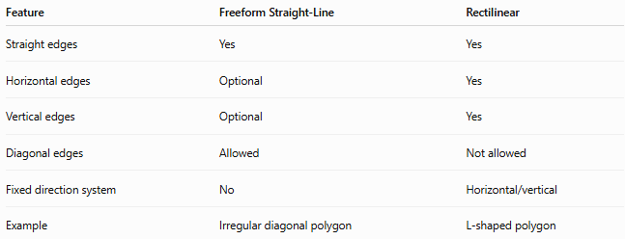
Feature | Freeform Straight-Line | Rectilinear
Straight edges | Yes | Yes
Horizontal edges | Optional | Yes
Vertical edges | Optional | Yes
Diagonal edges | Allowed | Not allowed
Fixed direction system | No | Horizontal/vertical
Example | Irregular diagonal polygon | L-shaped polygon
Therefore, every rectilinear shape is straight-edged, but not every freeform straight-line shape is rectilinear.

Examples

Example 1 — Irregular pentagon
# Source: AI Source: Provided by: [Data Path: Persons Table -> ID Column: 1, Name_En Column: Motasem Essam] -> From: [ChatGPT] on [7/25/2026]
A five-sided polygon with unequal side lengths and unequal angles can be a:
Freeform Straight-Line Shape
provided it does not follow a standard regular pattern.

Example 2 — Custom concave polygon
# Source: AI Source: Provided by: [Data Path: Persons Table -> ID Column: 1, Name_En Column: Motasem Essam] -> From: [ChatGPT] on [7/25/2026]
An irregular L-shaped polygon can be:
- Closed
- Simple
- Concave
- Straight-lined
- Freeform

Example 3 — Open polygonal path
# Source: AI Source: Provided by: [Data Path: Persons Table -> ID Column: 1, Name_En Column: Motasem Essam] -> From: [ChatGPT] on [7/25/2026]
A sequence of connected diagonal and horizontal segments that does not return to its starting point is:
Open Freeform Straight-Line Shape

Classification Summary
# Source: AI Source: Provided by: [Data Path: Persons Table -> ID Column: 1, Name_En Column: Motasem Essam] -> From: [ChatGPT] on [7/25/2026]
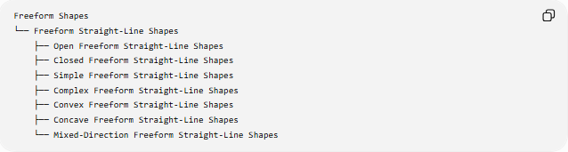
Freeform Shapes
└── Freeform Straight-Line Shapes
├── Open Freeform Straight-Line Shapes
├── Closed Freeform Straight-Line Shapes
├── Simple Freeform Straight-Line Shapes
├── Complex Freeform Straight-Line Shapes
├── Convex Freeform Straight-Line Shapes
├── Concave Freeform Straight-Line Shapes
└── Mixed-Direction Freeform Straight-Line Shapes
A more mathematical classification is:
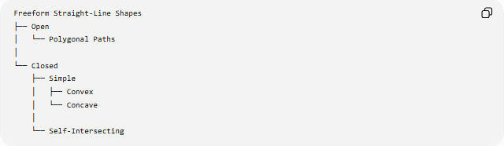
Freeform Straight-Line Shapes
├── Open
│ └── Polygonal Paths
│
└── Closed
├── Simple
│ ├── Convex
│ └── Concave
│
└── Self-Intersecting

Key Points
# Source: AI Source: Provided by: [Data Path: Persons Table -> ID Column: 1, Name_En Column: Motasem Essam] -> From: [ChatGPT] on [7/25/2026]
- Freeform Straight-Line Shapes are constructed primarily from straight-line segments without a fixed standard geometric form.
- A closed, simple freeform straight-line shape is a polygon.
- It may be convex or concave.
- It may be regular or irregular, although freeform shapes are commonly irregular.
- Open forms are polygonal paths rather than enclosed polygons.
- Self-intersecting forms require special treatment and should not automatically use simple-polygon formulas.
- Diagonal and oblique edges are allowed.
- Rectilinear shapes are more restricted because their edges must be horizontal or vertical.
- The shoelace formula can calculate the area of a simple closed polygonal freeform shape.

Conclusion
# Source: AI Source: Provided by: [Data Path: Persons Table -> ID Column: 1, Name_En Column: Motasem Essam] -> From: [ChatGPT] on [7/25/2026]
Freeform Straight-Line Shapes are flexible straight-edged forms created from line segments without following a predetermined standard geometric structure. They can be open or closed, simple or complex, convex or concave, and may use horizontal, vertical, diagonal, or mixed directions. When a freeform straight-line boundary is closed and non-self-intersecting, it is mathematically a polygon.

